Lovely professional university

Computer Science Engineering(CSE236)



REPORT

NAME = MUKUL GOND

REG.NO = 12109391

ROLL.NO = 30

SECTION = K21KA

SUBJECT = CSE(326)

QUESTION:-

Product and Service Compare on site:

Talk about two similar product or service?

Introductione

<!DOCTYPE HTML>

<html lang="en">

<head>

<meta charset="UFT-8">

<meta name="vieport" content"width=device-width, initial-scale=scale=1.0">

<title>MukulStore | Ecommerce website Design</title>

<link rel="stylesheet" href="style.css">

<link href="https://fonts.googleapis.com/css2?family=Poppins:wght@300;400;500;600;700&display=swap" rel="stylesheet">

<link rel="stylesheet" href="https://cdn.jsdelivr.net/npm/@fortawesome/fontawesome-free@5.15.4/css/fontawesome.min.css">

</head>

<body>

<div class="header">

<div class="container">

<div class="navbar">

<div class="logo">

<img src="images/logo.png" width="125px">

</div>

<nav>

<ul id="MenuItems">

  <li><a herf="">Home</a></li>

 <li><a herf="">Product</a></li>

 <li><a herf="">About</a></li>

 <li><a herf="">contact</a></li>

 <li><a herf="">Account</a></li>

</ul>

</nav>

<img src="images/cart.png" width="30px" height="30px">

<img src="images/menu.png" class="menu-icon"

 onclick="menutoggle()">

</div>

<div class="row">

<div class="col-2">

<h1>Give Your Workout<br>A New Style!</h1>

<p>success isn't always about greatness. It's about consistency.Consistent<br>hard work gain success.Greatness will come.</p>

 <a href="" class="btn">Explore Now &#8594;</a>

</div>

<div class="col-2">

<img src="images/image1.png" alt="image1">

</div>

</div>

</div>

</div>

<!-------- featured categories -------->

<div class="categories">

  <div class="small-container">

    <div class="row">

      <div class="col-3">

        <img src="images/category-1.jpg">

      </div>

      <div class="col-3">

        <img src="images/category-2.jpg">

      </div>

      <div class="col-3">

        <img src="images/category-3.jpg">

      </div>

    </div>

  </div>

</div>

<!-------- featured products -------->

<div class="small-container">

  <h2 class="title">Featured products</h2>

  <div class="row">

    <div class="col-4">

      <img src="images/product-1.jpg">

      <h4>Red printed t-shirt</h4>

      <div class="rating">

        <i class="fa fa-star"></i>

        <i class="fa fa-star" ></i>

        <i class="fa fa-star" aria-hidden="true"></i>

        <i class="fa fa-star" aria-hidden="true"></i>

        <i class="fa fa-star" aria-hidden="true"></i>

        <i class="fa fa-star-o" aria-hidden="true"></i>

      </div>

      <p>$50.00</p>

    </div>

    <div class="col-4">

      <img src="images/product-2.jpg">

      <h4>Red printed t-shirt</h4>

      <div class="rating">

        <i class="fa fa-star"></i>

        <i class="fa fa-star" ></i>

        <i class="fa fa-star" aria-hidden="true"></i>

        <i class="fa fa-star" aria-hidden="true"></i>

        <i class="fa fa-star" aria-hidden="true"></i>

        <i class="fa fa-star-o" aria-hidden="true"></i>

      </div>

      <p>$50.00</p>

    </div>

    <div class="col-4">

      <img src="images/product-3.jpg">

      <h4>Red printed t-shirt</h4>

      <div class="rating">

        <i class="fa fa-star"></i>

        <i class="fa fa-star" ></i>

        <i class="fa fa-star" aria-hidden="true"></i>

        <i class="fa fa-star" aria-hidden="true"></i>

        <i class="fa fa-star" aria-hidden="true"></i>

        <i class="fa fa-star-o" aria-hidden="true"></i>

      </div>

      <p>$50.00</p>

    </div>

    <div class="col-4">

      <img src="images/product-4.jpg">

      <h4>Red printed t-shirt</h4>

      <div class="rating">

        <i class="fa fa-star"></i>

        <i class="fa fa-star" ></i>

        <i class="fa fa-star" aria-hidden="true"></i>

        <i class="fa fa-star" aria-hidden="true"></i>

        <i class="fa fa-star" aria-hidden="true"></i>

        <i class="fa fa-star-o" aria-hidden="true"></i>

      </div>

      <p>$50.00</p>

    </div>

    <h2 class="title">Latest Products</h2>

    <div class="row">

      <div class="col-4">

        <img src="images/product-5.jpg">

        <h4>Red printed t-shirt</h4>

        <div class="rating">

          <i class="fa fa-star"></i>

          <i class="fa fa-star" ></i>

          <i class="fa fa-star" aria-hidden="true"></i>

          <i class="fa fa-star" aria-hidden="true"></i>

          <i class="fa fa-star" aria-hidden="true"></i>

          <i class="fa fa-star-o" aria-hidden="true"></i>

        </div>

        <p>$50.00</p>

      </div>

      <div class="col-4">

        <img src="images/product-6.jpg">

        <h4>Red printed t-shirt</h4>

        <div class="rating">

          <i class="fa fa-star"></i>

          <i class="fa fa-star" ></i>

          <i class="fa fa-star" aria-hidden="true"></i>

          <i class="fa fa-star" aria-hidden="true"></i>

          <i class="fa fa-star" aria-hidden="true"></i>

          <i class="fa fa-star-o" aria-hidden="true"></i>

        </div>

        <p>$50.00</p>

      </div>

      <div class="col-4">

        <img src="images/product-7.jpg">

        <h4>Red printed t-shirt</h4>

        <div class="rating">

          <i class="fa fa-star"></i>

          <i class="fa fa-star" ></i>

          <i class="fa fa-star" aria-hidden="true"></i>

          <i class="fa fa-star" aria-hidden="true"></i>

          <i class="fa fa-star" aria-hidden="true"></i>

          <i class="fa fa-star-o" aria-hidden="true"></i>

        </div>

        <p>$50.00</p>

      </div>

      <div class="col-4">

        <img src="images/product-8.jpg">

        <h4>Red printed t-shirt</h4>

        <div class="rating">

          <i class="fa fa-star"></i>

          <i class="fa fa-star" ></i>

          <i class="fa fa-star" aria-hidden="true"></i>

          <i class="fa fa-star" aria-hidden="true"></i>

          <i class="fa fa-star" aria-hidden="true"></i>

          <i class="fa fa-star-o" aria-hidden="true"></i>

        </div>

        <p>$50.00</p>

      </div>

  </div>

  <div class="row">

    <div class="col-4">

      <img src="images/product-9.jpg">

      <h4>Red printed t-shirt</h4>

      <div class="rating">

        <i class="fa fa-star"></i>

        <i class="fa fa-star" ></i>

        <i class="fa fa-star" aria-hidden="true"></i>

        <i class="fa fa-star" aria-hidden="true"></i>

        <i class="fa fa-star" aria-hidden="true"></i>

        <i class="fa fa-star-o" aria-hidden="true"></i>

      </div>

      <p>$50.00</p>

    </div>

    <div class="col-4">

      <img src="images/product-10.jpg">

      <h4>Red printed t-shirt</h4>

      <div class="rating">

        <i class="fa fa-star"></i>

        <i class="fa fa-star" ></i>

        <i class="fa fa-star" aria-hidden="true"></i>

        <i class="fa fa-star" aria-hidden="true"></i>

        <i class="fa fa-star" aria-hidden="true"></i>

        <i class="fa fa-star-o" aria-hidden="true"></i>

      </div>

      <p>$50.00</p>

    </div>

    <div class="col-4">

      <img src="images/product-11.jpg">

      <h4>Red printed t-shirt</h4>

      <div class="rating">

        <i class="fa fa-star"></i>

        <i class="fa fa-star" ></i>

        <i class="fa fa-star" aria-hidden="true"></i>

        <i class="fa fa-star" aria-hidden="true"></i>

        <i class="fa fa-star" aria-hidden="true"></i>

        <i class="fa fa-star-o" aria-hidden="true"></i>

      </div>

      <p>$50.00</p>

    </div>

    <div class="col-4">

      <img src="images/product-12.jpg">

      <h4>Red printed t-shirt</h4>

      <div class="rating">

        <i class="fa fa-star"></i>

        <i class="fa fa-star" ></i>

        <i class="fa fa-star" aria-hidden="true"></i>

        <i class="fa fa-star" aria-hidden="true"></i>

        <i class="fa fa-star" aria-hidden="true"></i>

        <i class="fa fa-star-o" aria-hidden="true"></i>

      </div>

      <p>$50.00</p>

    </div>

</div>

<!------- offer ------->

<div class="offer">

  <div class="small-container">

    <div class="row">

      <div class="col-2">

        <img src="images/exclusive.png" class="offer-img" alt="">

      </div>

      <div class="col-2">

        <p>Exclusively available at MukulStore</p>

        <h1>Smart band 4</h1>

        <small>the mi smart band 4 features a 39.9% larger (then mi band 3) AMOLED color full-touch display with adjustable brightness, so everthing is clear as can be.</small>

        <a href="" class="btn"> buy now &#8594; </a>

      </div>

    </div>

  </div>

</div>

<!---------testimonial-------->

      <div class="testimonial">

        <div class="small-container">

          <div class="row">

            <div class="col-3">

              <i class="fa fa-quote-left"></i>

              <p>Lorem Ipusm is simply dummy text of the printing and typesetting industry. Lorem Ipusm has been the industry's standard dummy text ever</p>

              <div class="rating">

                <i class="fa fa-star"></i>

                <i class="fa fa-star" ></i>

                <i class="fa fa-star" aria-hidden="true"></i>

                <i class="fa fa-star" aria-hidden="true"></i>

                <i class="fa fa-star" aria-hidden="true"></i>

                <i class="fa fa-star-o" aria-hidden="true"></i>

              </div>

              <img src="images/user-1.png">

              <h3>SEAN PARKER</h3>

            </div>

            <div class="col-3">

              <i class="fa fa-quote-left"></i>

              <p>Lorem Ipusm is simply dummy text of the printing and typesetting industry. Lorem Ipusm has been the industry's standard dummy text ever</p>

              <div class="rating">

                <i class="fa fa-star"></i>

                <i class="fa fa-star" ></i>

                <i class="fa fa-star" aria-hidden="true"></i>

                <i class="fa fa-star" aria-hidden="true"></i>

                <i class="fa fa-star" aria-hidden="true"></i>

                <i class="fa fa-star-o" aria-hidden="true"></i>

              </div>

              <img src="images/user-2.png">

              <h3>MIKE SMITH</h3>

            </div>

            <div class="col-3">

              <i class="fa fa-quote-left"></i>

              <p>Lorem Ipusm is simply dummy text of the printing and typesetting industry. Lorem Ipusm has been the industry's standard dummy text ever</p>

              <div class="rating">

                <i class="fa fa-star"></i>

                <i class="fa fa-star" ></i>

                <i class="fa fa-star" aria-hidden="true"></i>

                <i class="fa fa-star" aria-hidden="true"></i>

                <i class="fa fa-star" aria-hidden="true"></i>

                <i class="fa fa-star-o" aria-hidden="true"></i>

              </div>

              <img src="images/user-3.png">

              <h3>MABEL JOE</h3>

            </div>

          </div>

        </div>

      </div>

      <!-------- brands -------->

         <div class="brand">

           <div class="small-container">

             <div class="row">

               <div class="col-5">

                <img src="images/logo-godrej.png">

               </div>

               <div class="col-5">

                <img src="images/logo-oppo.png">

               </div>

               <div class="col-5">

                <img src="images/logo-coca-cola.png">

               </div>

               <div class="col-5">

                <img src="images/logo-paypal.png">

               </div>

               <div class="col-5">

                <img src="images/logo-philips.png">

               </div>

             </div>

           </div>

         </div>

<!---------------footer------------>

<div class="footer">

  <div class="container">

    <div class="row">

      <div class="footer-col-1">

        <h3>Download Our App</h3>

        <p>Download App for Android and ios mobile phone.</p>

        <div class="app-logo">

          <img src="images/app-store.png">

        </div>

      </div>

      <div class="footer-col-2">

        <img src="images/logo-white.png">

        <p>Our Purpose Is To Sutainnably Make the Pleasure and Benifits of sports Accessible to the Many.</p>

      </div>

      <div class="footer-col-3">

        <h3>Useful Links</h3>

        <ul>

          <li>Coupons</li>

          <li>Blog Post</li>

          <li>Return Policy</li>

          <li>Join Affiliate</li>

        </ul>

      </div>

      <div class="footer-col-4">

        <h3>Follow us</h3>

        <ul>

          <li>Facebook</li>

          <li>Twitter</li>

          <li>Instagram</li>

          <li>YouTube</li>

        </ul>

      </div>

    </div>

    <hr>

    <p class="copyright">copyrigth 2020 - Easy Tutorials</p>

  </div>

</div>

<!-------js for toggle menu------->

<script>

  var MenuItems =document.getElementById("MenuItems");

  MenuItems.style.maxHeight = "0px";

  function menutoggle(){

    if(MenuItems.style.maxHeight == "0px")

    {

      MenuItems.style.maxHeight ="200px";

    }

    else

    {

      MenuItems.style.maxHeight ="0px";

    }

</script>

</body>

</html>

Css/java-document

*{

    margin: 0;

    padding: 0;

    box-sizing: border-box;

}

body{

    font-family: 'Poppins', sans-serif;

}

.navbar{

    display: flex;

    align-items: center;

    padding: 20;

}

nav{

    flex: 1;

    text-align: right;

}

nav ul{

    display: inline-block;

    list-style-type: none

}

nav ul li{

    display: inline-block;

    margin-right: 20px;

}

a{

    text-decoration: none;

    color: #555;

}

p{

    color: #555;

}

.container{

    max-width: 1300px;

    margin: auto;

    padding-left: 25px;

    padding-right: 25px;

}

.row{

    display: flex;

    align-items: center;

    flex-wrap:wrap;

    justify-content: space-around;

}

.col-2{

    flex-basis: 50%;

    min-width: 300px;

}

.col-2 img{

    max-width: 100%;

    padding: 50px 0;

}

.col-2 h1{

    font-size: 50px;

    line-height: 60px;

    margin: 25px 0;

}

.btn{

    display: inline-block;

    background:#ff523b;

    color: #fff;

    padding:8px 30px;

    margin: 30px 0;

    border-radius: 30px;

    transition: background 0.5s;

}

.btn:hover{

    background: #563434;

}

.header{

    background: radial-gradient(#fff,#ffd6d6);

}

.header  .row{

    margin-top: 70px;

}

.categories{

    margin: 70px 0;

}

.col-3{

    flex-basis: 30%;

    min-width: 250px;

    margin-bottom: 30px;

}

.col-3 img{

    width: 100%;

}

.small-container{

    max-width: 1080px;

    margin: auto;

    padding-left: 25px;

    padding-right: 25px;

}

.col-4{

    flex-basis: 25%;

    padding: 10px;

    min-width: 200px;

    margin-bottom: 50px;

    transition: transform 0.5s;

}

.col-4 img{

    width: 100%;

}

.title{

    text-align: center;

    margin: 0 auto 80px;

    position: relative;

    line-height: 60px;

    color: #555;

}

.title::after{

    content: '';

    background: #ff523b;

    width: 80px;

    height: 5px;

    border-radius: 5px;

    position:absolute;

    bottom: 0;

    left: 50%;

    transform: translateX(-50%);

}

h4{

    color: #555;

    font-weight: normal;

}

.col-4 p{

    font-size: 14px;

}

.rating .fa{

    color: #ff523b;

}

.col-4:hover{

    transform: translateY(-5px);

}

/*-------- offer --------*/

.offer{

    background: radial-gradient(#fff,#ffd6d6);

    margin-top: 80px;

    padding: 30px 0;

}

.col-2 .offer-img{

    padding: 50px;

}

small{

    color: #555;

}

/*----------testimonial---------*/

.testimonial{

    padding-top: 100px;

}

.testimonial .col-3{

    text-align: center;

    padding: 40px 20px;

    box-shadow: 0 0 20px 0px rgba(0,0,0,0.1);

    cursor: pointer;

    transition:transform 0.5s;

}

.testimonial .col-3 img{

    width: 50px;

    margin-top: 20px;

    border-radius: 50%;

}

.testimonial .col-3:hover{

    transform: translate(-10px)

}

.fa.fa-quote-left{

    font-size: 34px;

    color: #ff523b;

}

.col-3p{

    font-size: 12px;

    margin: 12px 0;

    color: #777;

}

.testimonial .col-3 h3{

    font-weight: 600;

    color: #555;

    font-size: 16px;

}

/*---------------brands-------------*/

.brand{

    margin: 100px auto;

}

.col-5{

    width: 160px;

}

.col-5 img{

    width: 100%;

    cursor: pointer;

    filter: grayscale(100%);

}

.col_5 img:hover{

    filter: grayscale(0);

}

/*----------footer---------*/

.footer{

    background: #000;

    color: #8a8a8a;

    font-size: 14px;

    padding: 60px 0 20px;

}

.footer p{

    color: #8a8a8a;

}

.footer h3{

    color: #fff;

    margin-bottom: 20px;

}

.footer-col-1, .footer-col-2, .footer-col-3, .footer-col-4{

    min-width: 250px;

    margin-bottom: 20px;

}

.fopoter-col-1{

    flex-basis: 30%;

}

.footer-col-2{

    flex: 1;

    text-align: center;

}

.footer-col-2 img{

    width: 180px;

    margin-bottom: 20px;

}

.fopoter-col-3,.footer-col-4{

    flex-basis: 12%;

    text-align: center;

}

ul{

    list-style-type: none;

}

.app-logo{

    margin-top: 20px;

}

.app-logo img{

    width:140px;

}

.fopoter hr{

    border: none;

    background: #b5b5b5;

    height: 1px;

    margin: 20px 0;

}

.copyright{

    text-align: center;

}

.menu-icon{

    width: 20px;

    margin-left: 20px;

    display: none;

}

/*---------media query for menu --------*/

@media only screen and (max-width: 800px){

    nav ul{

        position: absolute;

        top: 70px;

        left: 0;

        background: #333;

        width: 100%;

        overflow: hidden;

        transition: max-height 0.5s;

    }

    nav ul li{

        display: block;

        margin-right: 50px;

        margin-top: 10px;

        margin-bottom: 10px;

    }

    nav ul li a{

        color: #fff;

    }

    .menu-icon{

        display: block;

        cursor: pointer;

    }

}

/*media query for less than 600 screen size*/

@media only screen and (max-width: 800px){

    .row{

        text-align: center;

    }

    .col-2,.col-3,.col-4{

        flex-basis: 100%;

    }

}

Websites:- <http://127.0.0.1:5500/>

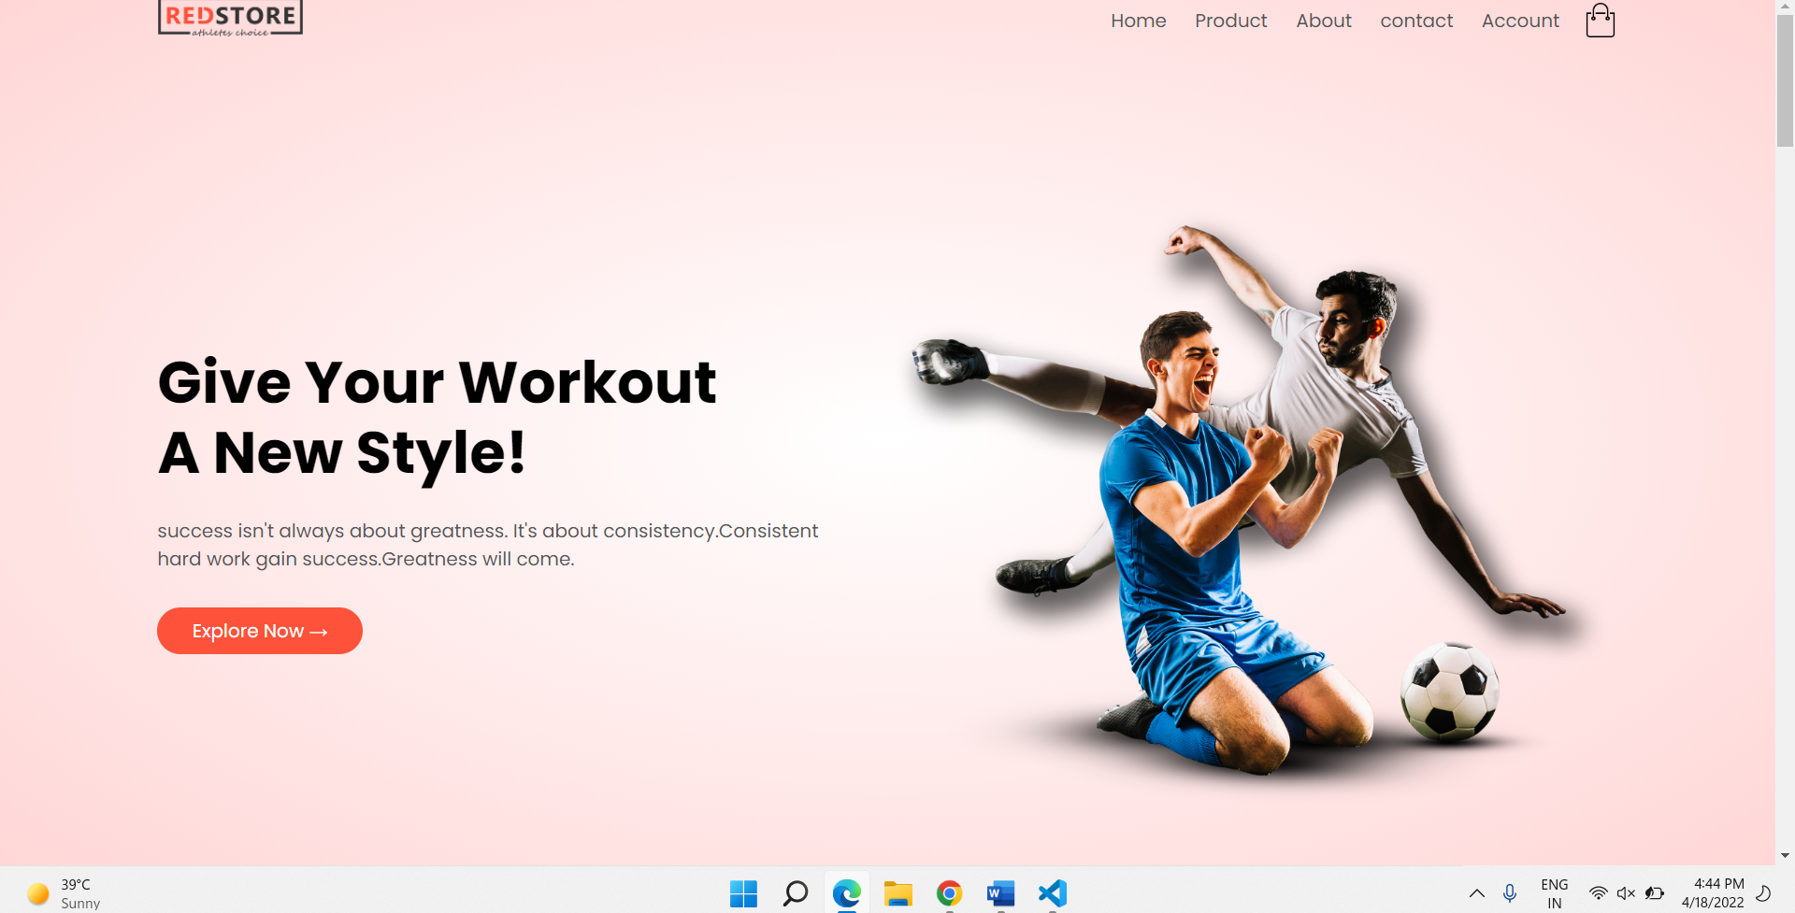

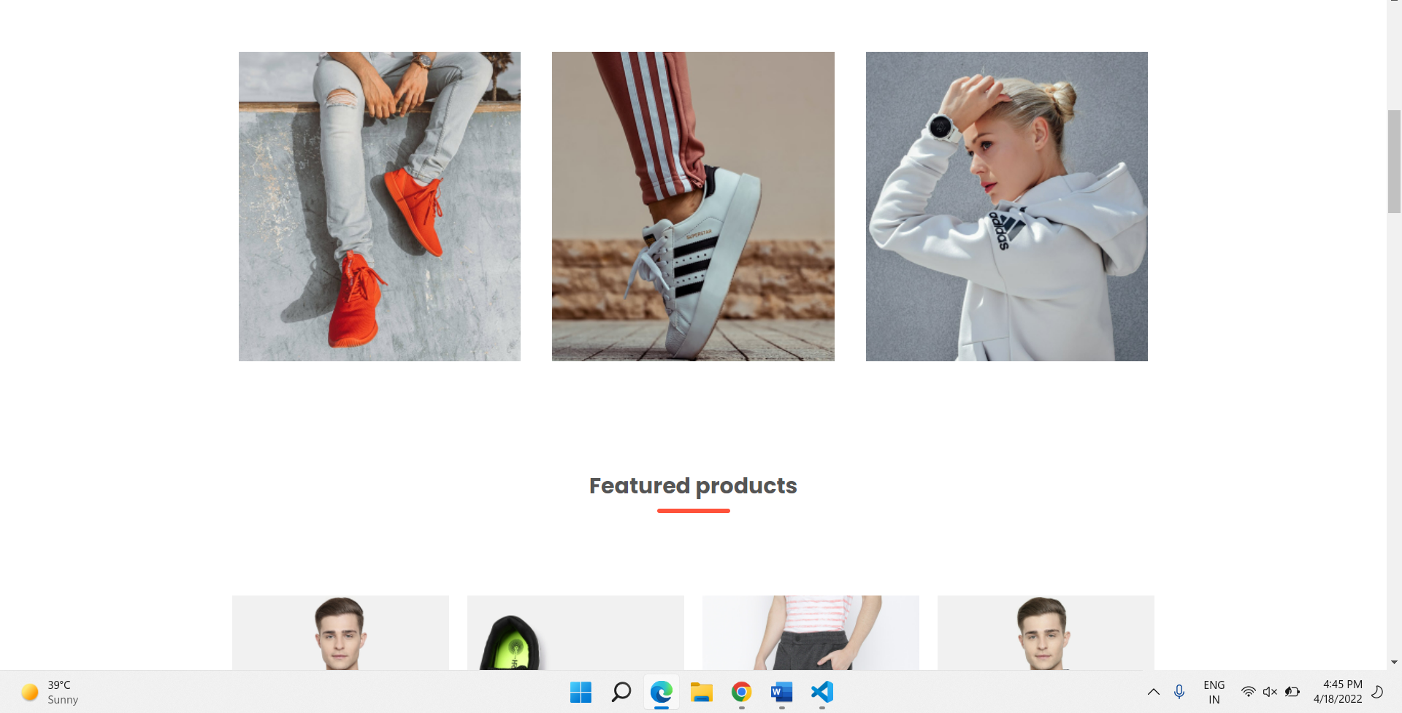

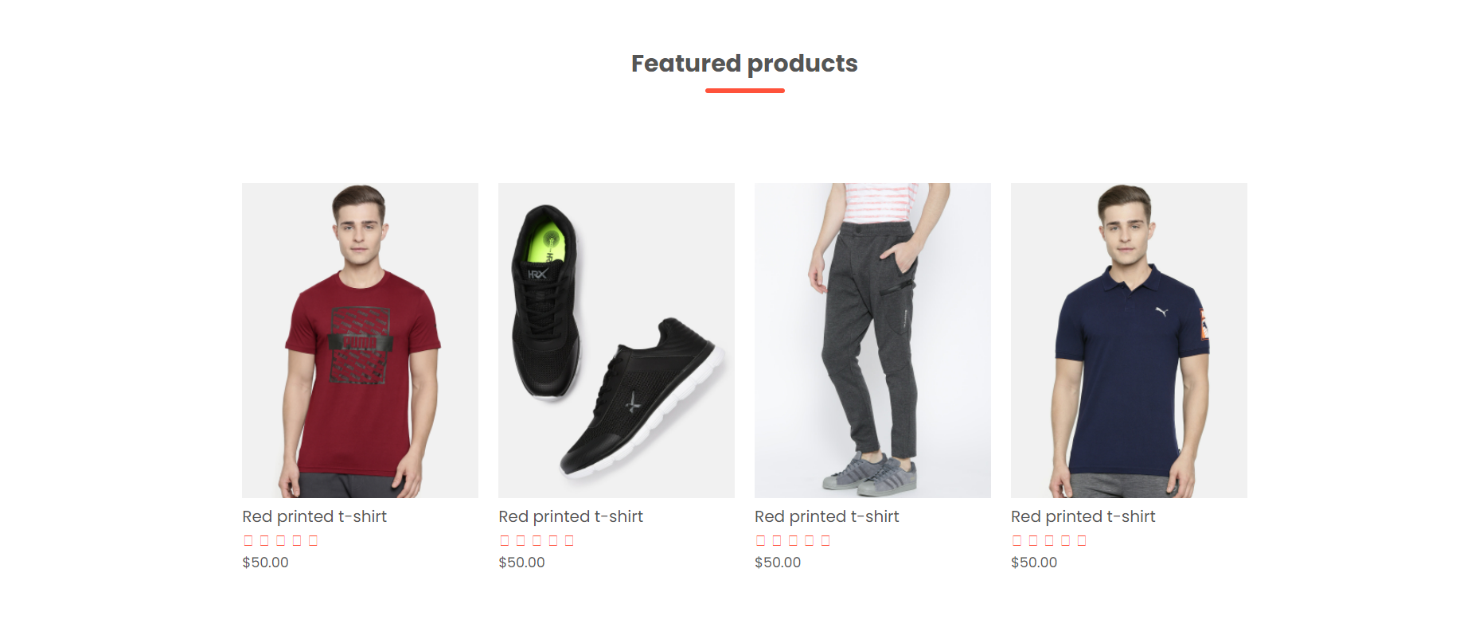

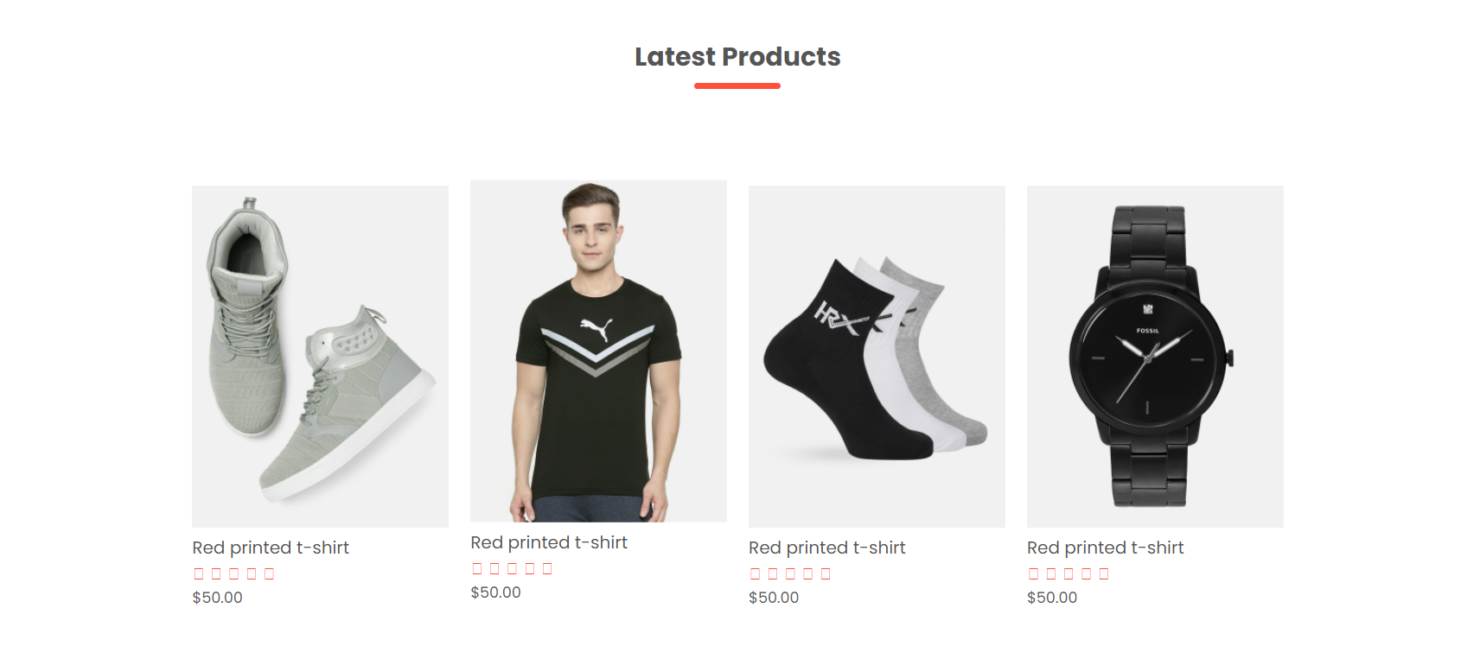

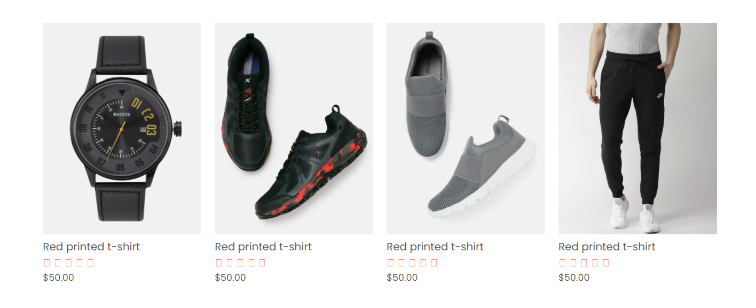

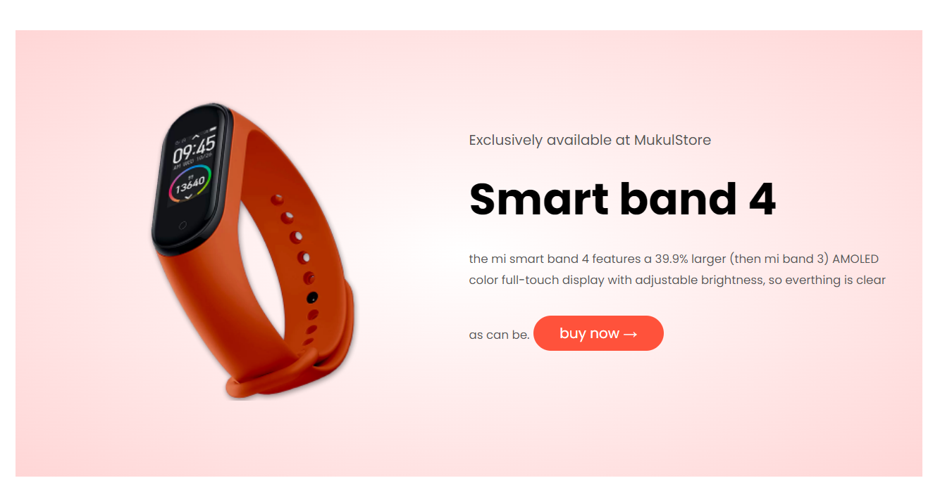

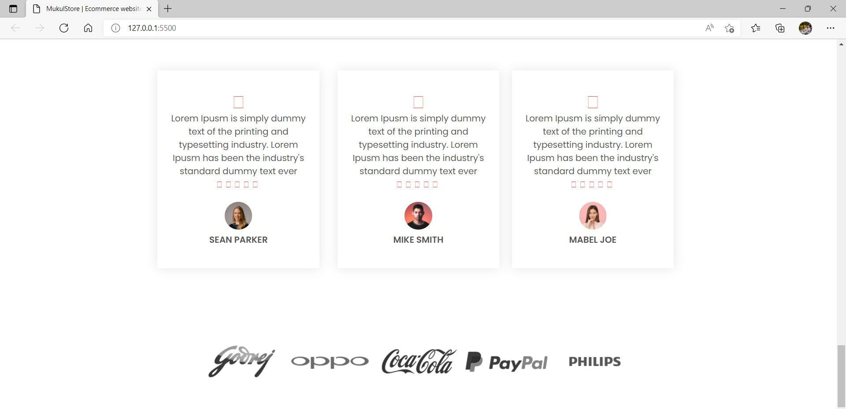

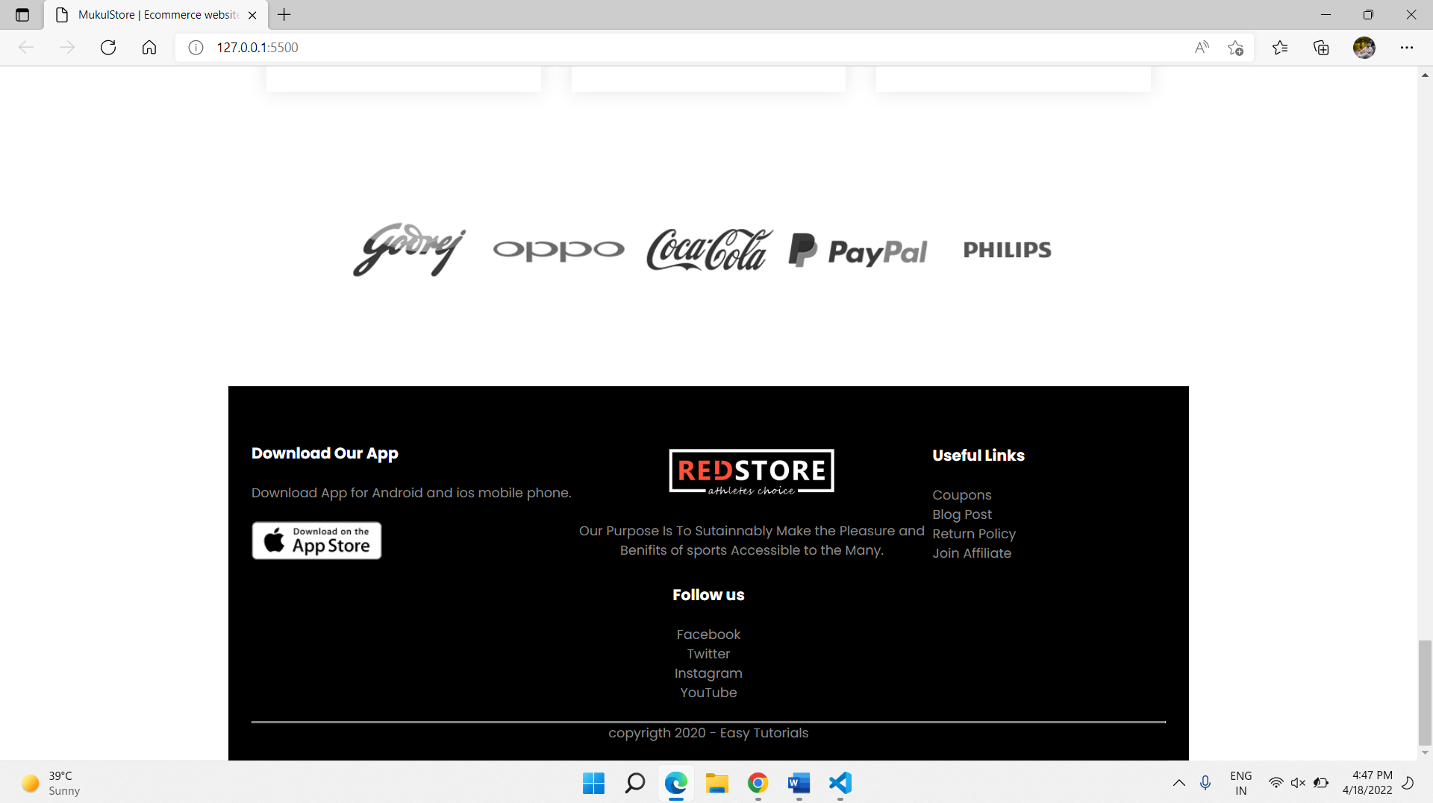

Conclusion:- HTML provides the basic structure of sites ,Which is enchange and modified by other technologies like CSS and JavaScript. CSS is used to control presentation, formatting, and layout.

JavaScript is used to control the behaviour of different element.

In this websites I, MUKUL used three way to create this websites is HTML ,CSS ,JavaScript.

In this websites we talk about Product and Service compar on sites. & Talk about two similar product and services.

Thank you

Respected mam:- mrs. pooja rana

Submitted by :- mukul gond